**TRAVEL BUDDY**

**A MINI PROJECT REPORT FOR THE COURSE**

**CB19501 DESIGN THINKING**

***Submitted by***

**VARADHARAJAN S**

**(221401112)**

**SANDEEP VISHWA R**

**(221401081)**

**TATIREDDY DINESH KUMAR**

**(221401102)**

**III YEAR B.Tech**

**COMPUTER SCIENCE AND BUSINESS SYSTEMS**



**Department of Computer Science and Business Systems**

**Rajalakshmi Engineering College**

**Thandalam, Chennai-602105**

**November 2024**

**BONAFIDE CERTIFICATE**

Certified that this Thesis titled “**TRAVEL BUDDY**” is the bonafide work of **VARADHARAJAN S** **(221401112)**,  **SANDEEP VISHWA R (221401081)** and **TATIREDDY DINESH KUMAR (221401102)** who carried out the work under my supervision. Certified further that to the best of my knowledge the work reported here in does not form part of any other thesis or dissertation on the basis of which a degree or award was conferred on an earlier occasion on this or any other candidate.

**Student Signature with Name**

1.

2.

3.

4

5.

Signature of the Supervisor with date

Dr. V. Murali Bhaskaran

Signature Examiner-1 Signature Examiner-2

**TABLE OF CONTENT**

**CHAPTER NO. TITLE PAGE NO.**

**ABSTRACT**

**LIST OF TABLES**

**LIST OF FIGURES**

**LIST OF SYMBOLS, ABBREVATION**

1. Introduction
   1. Design Thinking Approach
   2. Stanford design thinking module
2. Literature Review
3. Domain area
4. Empathies stage
5. Define stage
6. Ideation stage
7. Prototype stage
8. Test and feedback
9. Re-design and implementation
10. Conclusion
11. Feature work
12. Learning outcomes

Reference

* Journal paper
* Website

**ABSTRACT**

Visiting new destinations always a brings in thrill and curiosity, But the challenge is that you have to step into the unknown adjusting to local customs or even looking for reliable information about the place. To solve these “Travel Buddy” is a platform that would help the travellers to connect with locals who are called as ‘buddies’ in our app and well-aware about their city so that the traveller could make most out of their trip.

Firstly, Travel Buddy is all about connecting travellers with real people. When a traveller is looking for something specific, such as hidden secrets about the city, language help or cultural advice, buddies are at their disposal to give that helping hand, making travels an overall easier and more enriching experience. This allows travellers to experience new destinations with more confidence

It also gives the locals who work with it a platform to share their expertise and love of their City. It is giving them a way to make money as they market their community and culture. This end-to-end interchange helps in connecting locals with travellers, benefiting both individuals in turn and as they progress through each other.

It is an beyond service, it lets you create relationships that last without borders a spot to meet people from everywhere in the world. Made buy travellers for travellers, the platform encloses the gap between those who travel and the destinations they encounter, ensuring each journey is a story worth telling.

**LIST OFTABLES**

|  |  |  |
| --- | --- | --- |
| **S.NO** | **TABLE NAME** | **PAGE NO** |
| 1. | Overview of Design Thinking Stages for Travel Buddy | 10 - 11 |
| 2. | Features and Functionalities of Travel Buddy | 19 |
| 3. | Working of Travel Buddy | 22-23 |

**LIST OF FIGURES**

|  |  |  |
| --- | --- | --- |
| **S.NO** | **TABLE NAME** | **PAGE NO** |
| 1. | Double – Diamond Model | 8 |
| 2. | Stanford Design Thinking Model | 9 |
| 3. | Mindmap | 17 |
| 4. | Prototype for Travellers | 20 |
| 5. | Prototype for Buddy | 21 |

**SYMBOLS &ABBREVATION**

1. OTAs - Online Travel Agencies
2. MFA - Multi-Factor Authentication
3. QA - Quality Assurance
4. B2B - Business-to-Business
5. C2C - Consumer to Consumer
6. B2C - Business to Consumer
7. SVG - Scalable Vector Graphics

**1.INTRODUCTION**

Travel Buddy is a service which links tourists to local guides and provides them personal assistance as well as their views that make wandering new lands convenient and rewarding. If you are travelling abroad or a new city, to get some reliable and local advice can help. Enter Travel Buddy, a platform that connects travellers with locals—referred to as buddies—who knows the region well and can offer customized recommendation and assistance on the ground.

The platform makes travellers’ trips more enjoyable and gives locals to offer a piece of their culture, knowledge or skills by creating a source of revenue. Travel Buddy makes these connections meaningful in order to have a real travel experience that travellers could enjoy by having a help from locals sharing the soul of city.

* 1. **DESIGN THINKING APPROACH – DOUBLE DIAMOND MODEL**

The Double Diamond Model, by the British Design Council, is an illustration of the design process, which can be divided into four steps: Discover, Define, Develop, and Deliver. With the application of this model to the Travel Buddy project, each stage would serve towards refinement, satisfying the needs of a traveller and guiding the service appropriately.

**1. Discover**

We're trying to understand the problem space by gathering insights from travellers and guides. Through interviews, surveys, and user research, we understand the issues that the travellers are seeking reliable local guides and the guides lack clients. That is quite a broad understanding of how travel can be made better using digital channels. We also look at the current services that are available today, such as Couchsurfing and ToursByLocals, to get an idea of what's working and what's not so we're not reinventing the wheel​.

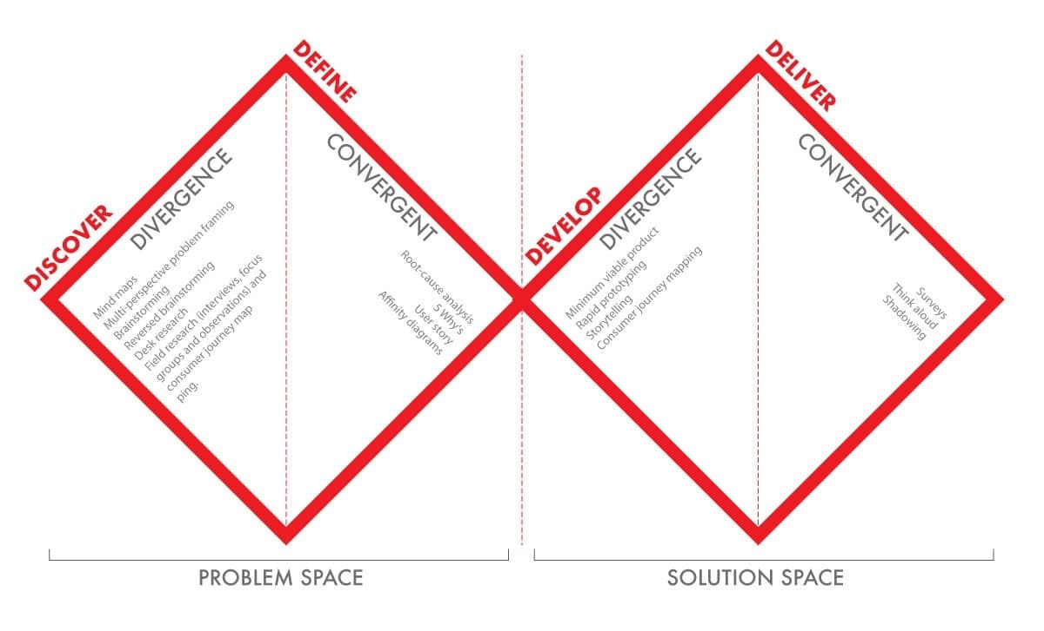

**2. Define**

Now, once the need to gather data has been ascertained, we refine our attention by focusing on specific user needs and pain points related to use. For example, problems with Travel Buddy might involve its inability to check the credentials of guides or its failure to have customized travel experiences. We create user personas, such as first-timers or lone wanderers, and craft problem statements around them.

**3. Design**

During the Develop phase, we would begin to brainstorm ideas about creating solutions for identified issues. Drawing insights from the Define phase, we would brainstorm ways of implementing an easy-to-use platform. Solutions may encompass integrating a rating system for guides, or a robust verification process, or a personalized travel plan generator.

**4. Deliver**

Lastly is the Deliver phase, whereby the prototypes are taken to real users, and their feedback is gathered and used in iterating the design. This is done by releasing a beta to a very small set of users, getting their feedback on the user interface, and, based on the experience, making modifications.

* 1. **STANFORD DESIGN THINKING MODULE**

The Stanford Design Thinking Model is a systematic approach that helps to develop user focused solutions in iterative manner.

**1.Empathize:**

It starts with knowing the voice and buyer persona. This means that Travel Buddy listens to potential travellers and guides to understand the problems they face (e.g. managing their travel plans, attractions or UI pain points). User Research: Phase 1 User research begins with interviews, surveys, user observation to get a more detailed on the experiences and behaviours they unfold there was a time or ends.

**2.Define:**

User problems and needs from discovery of insights gathered. Creating a problem statement that sums up the synthesis of information “Travelers need an easy-to-use system for tracking details of their travel while they need to be able to communicate with guides in a predictable way, all keeping our data secure”.

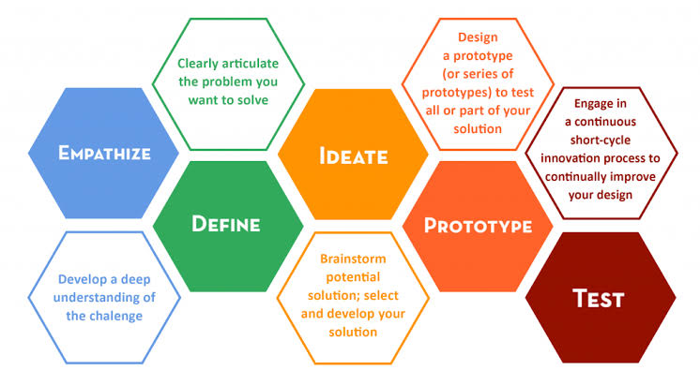

**3.Ideate:**

Using the problem above, our team brainstorm the ideas. For Travel Buddy that may consist of brainstorming feature-ideas like secure login methods, clean forms for international users or real-time alerts while travelling. Rather, the idea is to look at a variety of solutions that can be applied.

**4. Prototype:**

Travel Buddy will have the prototype with its suggested solutions. These can be anything from simple wireframes of the user interface to mock-ups of the registration process, and even stubs for data entry. Prototyping gives the team a medium to rapidly visualize and test ideas, providing an opportunity to refine designs quickly.

**5. Testing**

The last stage is to give the prototypes to real users and ask for their feedback. Specifically, Travel Buddy has completed usability testing with travellers and guides on multi-factor authentication and country code selection for the phone while running pilots to deal with all UX related issues. It captures feedback, which can be used to identify where improvements are needed and ensure that the platform meets user requirements efficiently.

**1.Overview of Design Thinking Stages for Travel Buddy**

| **Stage** | **Description** | **Key Activities in Travel Buddy** |
| --- | --- | --- |
| Empathize | Understand the users (travellers and guides), their needs, and the challenges they face in the travel ecosystem. | Conduct interviews with potential users, surveys, and field research to identify pain points like trustworthiness of guides, safety, and ease of planning. |
| Define | Synthesize the information gathered to clearly define the core problems travelllers face. | Create problem statements such as "How might we ensure safe and verified guide services for solo travelers?" |
| Ideate | Brainstorm potential solutions to the defined problems, focusing on user needs and innovative approaches. | Generate ideas such as using a real-time review system, integrating verified local guides, or providing tailored trip recommendations based on past user feedback. |
| Prototype | Develop a simplified version of the platform to test core features with actual users. | Create basic mock-ups or wireframes of the platform’s key features, such as guide verification and traveller-to-guide matching. |
| Test | Test the prototypes with real users and gather feedback on the functionality and user experience. | Pilot the platform with a small group of users and collect feedback on usability, effectiveness, and overall satisfaction with the guide-traveller matching and trip planning process. |
| Re-Design | Based on the feedback from testing, iterate and improve the platform's design and features to better meet user needs. | Redesign features like registration, guide verification, and user interface based on feedback to enhance usability and fix any issues related to security or efficiency. |
| Implementation | Launch the platform after final modifications, ensuring all key features work seamlessly and meet user expectations. | Deploy the Travel Buddy platform with all essential features, ensuring that all user feedback has been addressed and that the platform is ready for broader use. |
| Learning Outcomes | Reflect on the insights gained from the project, including challenges faced and lessons learned about the travel industry and platform development. | Key learnings include the importance of user feedback, security in travel services, and the impact of trust on platform success, alongside technical insights about scaling the platform effectively. |

1. **LITERATURE REVIEW**

**1. Travel and Tourism in the Digital Age**

The rapid pace of development in digital technology has greatly impacted the travel and tourism industry. Plans, bookings, and even the experience of traveling have undergone such strong evolution. And as many studies show, it is indeed true that digital platforms are central to connecting the travelller with guides, accommodations, and experiences (Buhalis, 2019). More in the direction of custom and flexible options, the traditional travel industry has evolved, with OTAs, mobile apps, and peer-to-peer platforms like Airbnb moving it along. With increasing popularity, travellers are attaching to various platforms that provide contact with local guides or fellow travellers in pursuit of unique experiences, which can be tailored to specific needs and appeal beyond typical tourism packages (Fitzpatrick, 2019). Regarding this shift, the Travel Buddy project therefore takes up offering a platform that connects similarly-minded travellers and guides to curate specific experiences.

**2. Peer-to-Peer Platforms: Definition and Growth**

A host of traditional industries has been revolutionized due to the advent of the sharing economy in travel. Peer-to-peer platforms are an interface that enables users to connect peer-to-peer, bypassing the middleman. Traveling, therefore, becomes an experience which seeks the more localized, authentic experience that online travel platforms like Couchsurfing, Meetup, or even ToursByLocals have created in niches. Further research delves into the fact that aspirations constantly change in the minds of travellers, as they go on to search for authenticity in their immergence with a broad stretch of cultures and communities involved (Richards, 2018). Travel Buddy adheres to this, offering an interface whereby travellers can meet with locals, commonly known as guides, to enhance their travel experience thereby offering customized tourism mentorship and experiences that may not be easily offered by other travel companies.

**3. Tourism Companion Services**

The element of the travel companion has been present in several works but, in most cases, it centers on one backpacker seeking companionship during their travels (Paris, 2017). Social interaction and safety are among the prime movers for travellers who are in pursuit of traveling with companions. Studies also highlight the fact that trust builds up in such platforms as connection with strangers for travel can be concerned with safety and reliability. Thus, Travel Buddy adds verification systems and reviews with the intention of building a trusting relationship between travellers and guides, thereby ensuring a safe and enjoyable experience for all users.

**4. Design Thinking in Travel Platforms**

Travel platforms have shown the application of the design thinking practice as an emphasis on experience, empathy, and development in iterations. In the case of Travel Buddy, the design thinking approach allows for designing and applications of principles such as empathy on user needs and pain points that a traveller is experiencing in real time. As a matter of fact, research favours the notion that platforms which pay more attention to understanding user behaviour and needs tend to increase satisfaction rates as well as involvement among users (Liedtka, 2018).

**5. Sustainability and Responsible Tourism**

Quite recently, sustainability and responsible tourism have been the focus of recent research. A current traveller acquires knowledge not only about destinations but also senses and becomes conscious about the environment, too; thus, desires travel alternatives with the least possible ecological footprints (Gössling & Hall, 2016). Platforms are becoming popular based on low-impact travel and the involvement of the community with the locals. Travel Buddy can develop strategies that promote local guides, allowing it to incorporate aspects of sustainability and protect environmentally friendly travel alternatives such as walking tours or eco-friendly accommodation and cultural immersion.

**3.DOMAIN AREA - TRAVEL & TOURISM**

Travel and tourism is that type of industry where things changes every day around the world with technological advancement. In the age when travellers are demanding frictionless and customized journeys, platforms like Travel Buddy appear to have found that sweet spot. With capabilities to support strong user-authentication techniques as per need.

Given the industry trends towards digital solutions, this underscores part of why merging real-time data and be spoke services together is important. Travel Buddy fits this way by offering personalized features to meet the unique needs of each traveller, from tailored features to instant notifications. This flexibility allows its users to seamlessly plan their trips and stay informed during their travels.

**4.EMPATHIZE STAGE**

In the Stanford Design Thinking model, the Empathize stage is used to make sure that we design solutions from a place of deep empathy with the end users. In case of Travel Buddy, this stage would be to meet different travellers and guides, understand their experiences and what they want & rectifying their pain points.

**Gaining a traveling perspective**

All types of travellers, face lot of complexities while managing travel plans. In the empathize phase, we did extensive user research to better understand what they go through every day. Through our research we determined common issues travellers face included.

**Managing Multiple Bookings:**

Users were irritated by dealing with flights, hotels, and tours that sit in different platforms. We have seen many of these travellers travel Not bearing in Mind significant Information and Facts or having lost their reservation number or wont retrieve it.

Travelers put concern for their data security at a high level when making online bookings. This is a great answer that solves both the former problems and the heavy concerns mentioned above: A platform which can offer ease of use but still with strong security.

**Language barriers and Local Assistance:**

While travelling overseas visitors face a lot of language issues, hence look for platforms which can give them local counselling and help. They wanted an app that would give them access to locals as their guides on the go.

**Interacting with the Guides Community**

The other primary user group, the guides, have their own complicated issues to work through. Travel Buddy interviewed various tour guides in different regions, interviewing them and holding focus groups in the empathize stage.

Many local guides said they had trouble finding customers to market themselves to travellers. Most of the time they operate based on word-of-mouth or use outdated booking systems.

**Communication Issues:**

Just like travellers, guides occasionally have communication issues, particularly when interacting with international visitors. Better tools that enable multilingual real-time communication were mentioned in many manuals.  
Travel Buddy has focused on developing a platform that not only links them with travellers but also helps them to market their services more successfully and keep in touch with their clients regardless of language or location after learning about these pain points straight from the guides.

**Impact of Development**

The development of Travel Buddy is immediately impacted in a few key ways by the insights obtained during the empathy stage. To start, the platform addresses passengers' worries around data privacy by placing a strong emphasis on user security.

**5.DEFINE STAGE**

The Stanford Design Thinking process's Define stage is essential for combining insights from the empathize stage and explicitly defining the issues that the platform seeks to address. This phase, for Travel Buddy, converts customer complaints into manageable problem statements to direct the creation of significant fixes.

**Identifying Key Problems for Travellers**

From the empathize stage, a number of significant issues that travellers frequently encounter surfaced. In order to ensure that the development team can concentrate on fixing the main problems, the following problem statements have been carefully constructed.

**Problem 1: Handling Inconsistent Travel Data**

Travelers need a means to manage all of their reservations for flights, hotels, and excursions in one location. The way things are now done requires customers to switch between different platforms, which causes confusion and inefficiency.

**Problem 2: Safeguarding Information While Traveling**

Because data breaches and insecure systems are common, travellers are worried about the security of their financial and personal information when using online travel platforms.

**Problem 3: Overcoming Communication and Language Barriers**

When visiting foreign destinations, international travellers often struggle with communication. They need a way to easily communicate with local guides in real-time without having to worry about language barriers.

These problem statements draw attention to the particular difficulties faced by travellers, such as the logistical requirement for consolidating travel information and the technical requirement for data protection.

**Defining Problems for Guides**

Travel Buddy aims to tackle the distinct difficulties that guides encounter. We have identified the following important problem statements for guides by examining input from the empathize stage:

**Problem 1: Having Trouble Reaching and attracting Customers**

Guides need a way to effectively market their services to travellers because the platforms they are currently using are either out-of-date or have limitations, which limits their access and visibility to potential customers.

**Problem 2: Inconsistent Employment Opportunities**

During off-peak travel seasons, guides struggle to maintain consistent work, which results in income instability and under utilization of their services.

**Problem 3: Coordinating and Communicating with Passengers**

It is challenging for guides to offer prompt assistance and coordination to foreign visitors because to language hurdles and time zone differences, therefore they require a dependable means of real-time communication.

By identifying these concerns explicitly, Travel Buddy can concentrate on creating features that address these fundamental challenges. Some of these features include a platform for guides to advertise their services, resources for year-round employment, and real-time communication capabilities with support for language translation.

**Framing the Design Challenge**

Defining the design issue in a way that the product team can implement is the aim of the define stage. The difficulties and insights that are discovered are utilized to develop a core design challenge that will direct the ideation and prototyping stages. One way to phrase the Travel Buddy design challenge is:

How might we create a seamless, secure travel management platform that allows travellers to easily manage bookings, communicate with guides, and feel confident about the security of their personal information, while also providing guides with tools to market their services and connect with travellers in real-time?"

**Effect on Upcoming Development**

Travel Buddy's development will be directly impacted by the insights gathered during the define stage. The product team can now start developing particular solutions, such safe login procedures, integrated dashboards for trip reservations, and real-time chat capabilities for guide-traveller contact, as they have a clear idea of the issues and goals.

**6.IDEATION STAGE**

In the Stanford Design Thinking process, creativity is most highly promoted at the Ideation stage. This stage entailed creating possible solutions to the problems that were determined to have been found using the insights obtained from the Define and Empathize stages. The ideation phase of Travel Buddy was engaged in developing a wide range of concepts that meet the needs of guides and travellers alike.

**Mindmap**

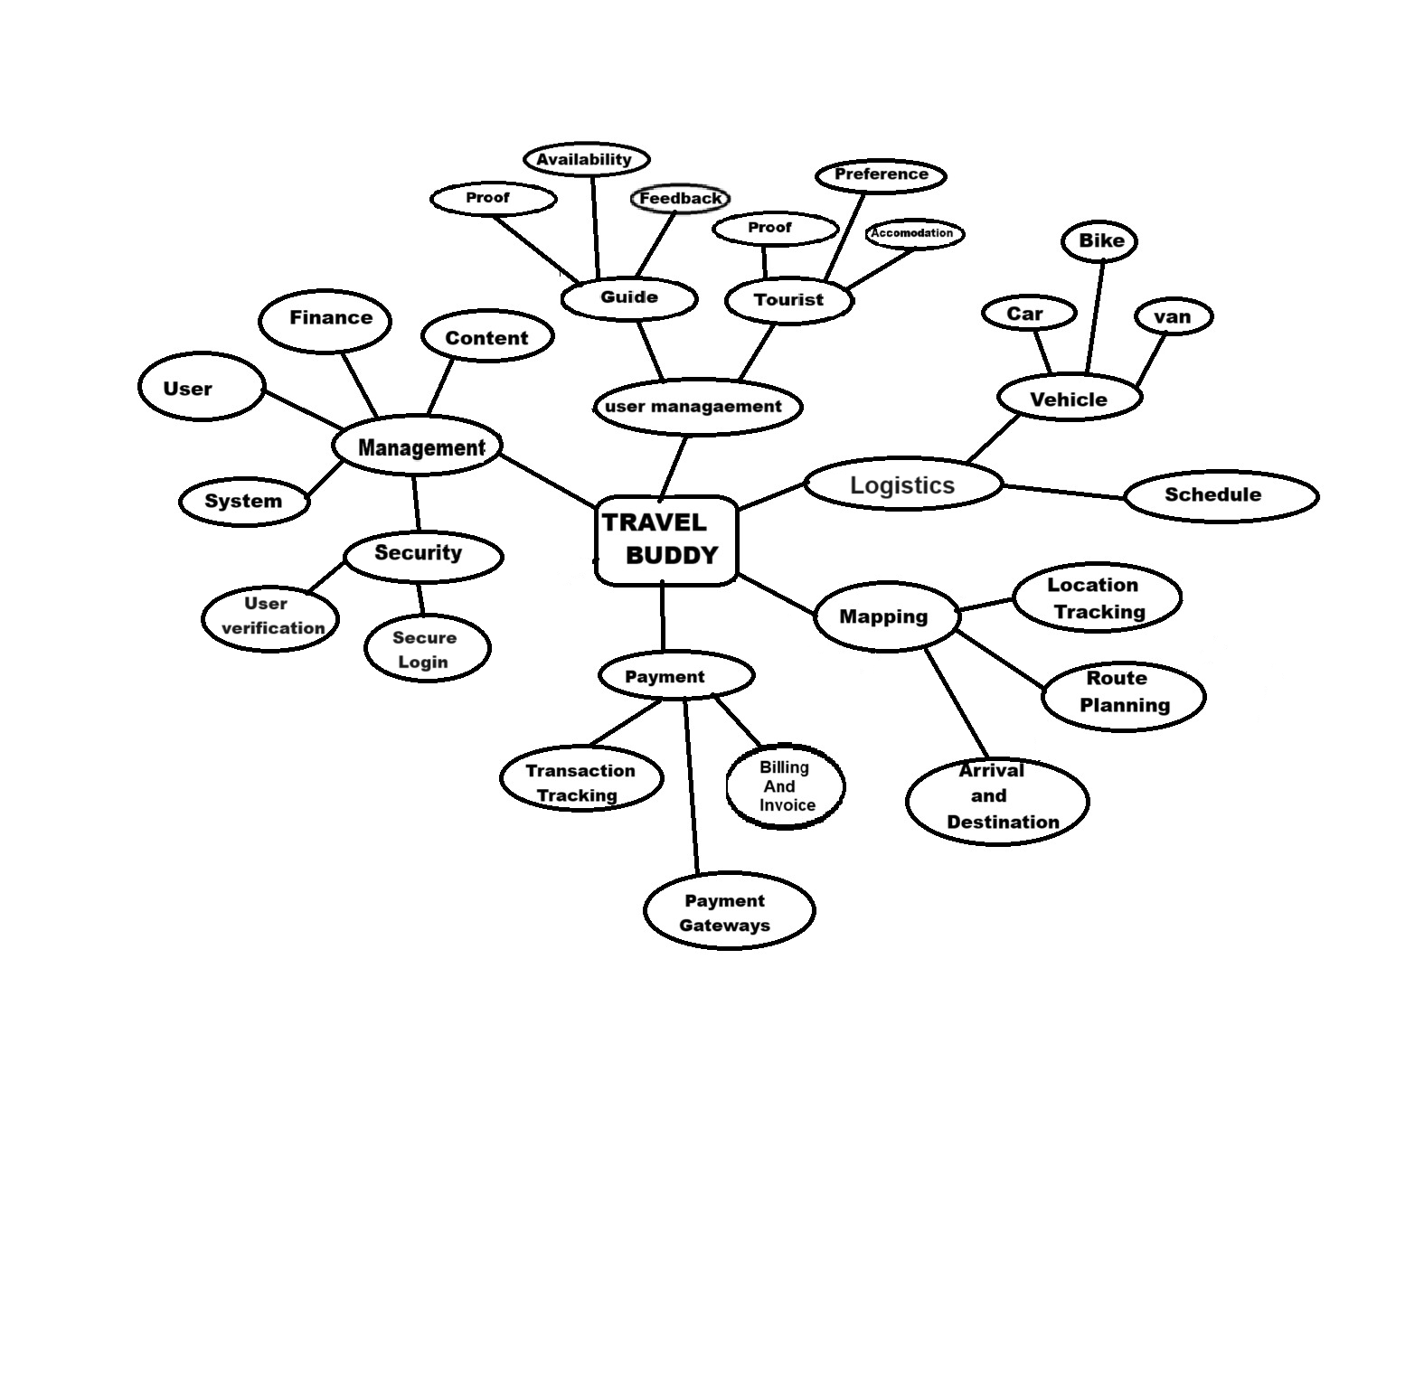

**Travel Solutions Development**

The ideation phase is to find solutions to the major pain points identified earlier when traveling, like managing trip reservations, data security, and the elimination of barriers while communicating with guides locally. One of the most innovative concepts was the centralized trip planner that enables users to manage all reservations-including hotels, and activities-through a single interface.

**Virtual Guide Assistant**

With it, there came the concept of a virtual guide assistant providing language interpretation and recommendations and insider knowledge to the on-the-go traveller. All this information would be available to travellers with no language and communication barrier due to the customized help AI and location-based services would render.

**Ideas on Generating Guides**

For the guides, some ideas developed in the ideation phase involved addressing the issues of marketing services, management of bookings and communication with international clients. Some key ideas that appear to emerge for the guides, among others, are:

**Dynamic Profile Builder:**

A feature call was proposed Dynamic Profile Builder. This feature would enable guides to build profile pages that are visually richer with multimedia - videos and images and reviews and more to attract more travellers to them. So, a guiding principle was to make guides distinct from all others by emphasizing their local knowledge and making it even more personalized to their profile based on services offered.

**Real-Time Availability Tracker:**

Improvement in booking could be made possible by creating a Real-Time Availability Tracker. Guides could update their presence in real-time so as not to double-book events and utilize their time to the fullest. Travelers could view the real-time calendar of the tour guide and make their bookings from there, thereby making the booking process smooth for all.

**Multilingual Chat feature**

This concept was also talked about because guides sometimes cannot clearly communicate with tourists, and this could immediately translate the guides' conversations with tourists into their original language using technology. As such, there would be no more communication barriers among guides, while communicating with clients from other countries.

**Traveler-Guided Review System:**

It is a kind of review system that was proposed to establish trust between travellers and guides. For each of his travels, each traveller would be required to leave reviews. Guides would then have the opportunity to address these reviews and, thus help build their reputation together with improving services according to experiences from such reviews among the travellers.

**Emergency Support System:**

This is a prevalent idea during ideation where the Emergency Support System comes into existence. This facility will provide immediate contact with emergency numbers, safety guidelines, and assistance to visitors while keeping them safe.

**2.** **Features and Functionalities of Travel Buddy**

| **Feature** | **Description** | **Target User** | **Current Functionality** | **Future Improvements** |
| --- | --- | --- | --- | --- |
| Traveller Registration | Allows travellers to create accounts, provide personal information, and set up travel preferences. | Travellers | Simple form with name, email, phone, password. | Add social media login, automatic verification, and preferred guide feature based on user reviews. |
| Guide Registration | Enables local guides to register, list services, and provide verification documents. | Local Guides | Basic registration with verification documents. | Implement guide certification, instant background checks, and reviews to enhance trust. |
| Search and Match | Travelers can search for guides based on location, availability, and past reviews. | Travellers and Guides | Search based on location and date. | Add filters like guide language, activity specialization, and price range. |
| Messaging System | Direct communication between travellers and guides to arrange tours and ask questions. | Travellers and Guides | Basic text-based chat with no media sharing. | Add media sharing (e.g., images, videos), real-time translation, and group chat functionalities. |
| Review and Rating | Travelers can review guides after a trip, rating them on various aspects such as safety and knowledge. | Travellers and Guides | 5-star rating system, written reviews allowed. | Implement weighted ratings, video reviews, and AI-based sentiment analysis to highlight trusted guides. |
| Trip Planning Assistant | Suggests personalized travel itineraries based on preferences and location. | Travellers | Manual itinerary creation by users. | Implement AI-based itinerary suggestions, and automated bookings for accommodation, transport, and guides. |
| Secure Payment Gateway | Travelers can pay for guide services securely through the platform. | Travelers and Guides | Payment processing via third-party service. | Add local currency options, split payments for groups, and integration with other travel services (e.g., Uber). |
| Multilingual Support | Supports various languages for international travelers and guides. | Travelers and Guides | Limited language options (English, Hindi). | Expand language support to include major global languages and integrate real-time language translation. |

**7.PROTOTYPE STAGE**

In the Stanford Design Thinking model, the Prototype stage refers to reifying ideas into testable, usable solutions that can be iterated upon. Thus, for Travel Buddy, the prototype stage is focused on low-fidelity versions of key feature implementations that will allow the team to actually envision, test, and refine the actual platform before full-scale development.

**Prototyping for Travellers**

Using what was learned from the empathize and define stages, several features were identified as key for the needs of the traveller. In the prototyping stage, the focus of Travel Buddy is to develop interactive models of the key features:

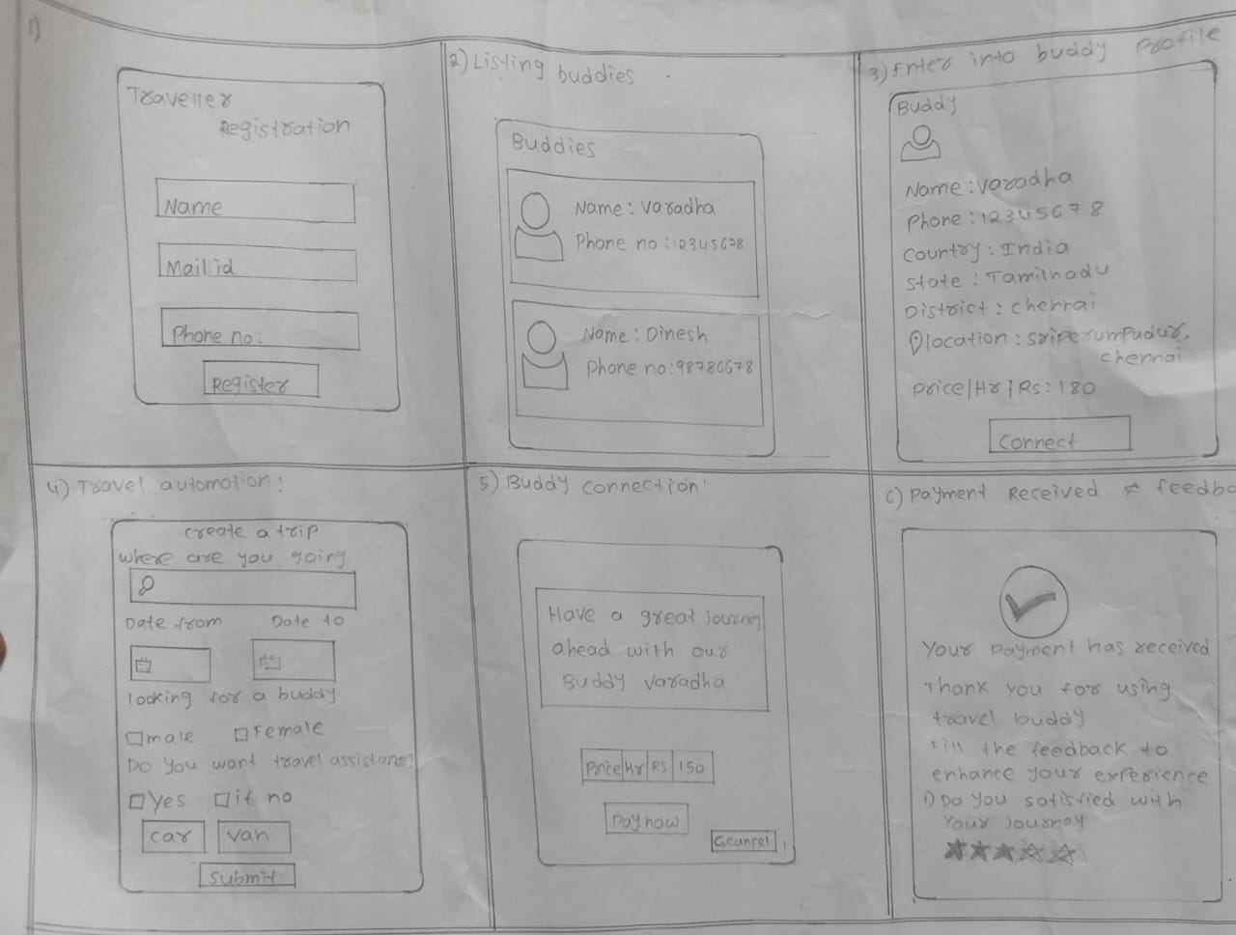

**Centralized Booking Dashboard:**

Another major pain point for travellers is the management of multiple bookings across several platforms. To eliminate this headache, Travel Buddy prototyped a central booking dashboard, where all data on bookings are congregated in a single place. In the interface, a traveller can see hotel reservations, and activity arrangements. Thus, the prototype concentrates on its use with intuitive navigation and easy features, each sufficiently clear in its structure, and with ease with which one can change or cancel bookings.

**Secure Login and Data Protection:**

As the fear of data exposure is in everyone's minds, Travel Buddy really prototypes a secure login mechanism with MFA. This prototype focuses on the usability of users so as to be able to easily register and log into such a system by providing a secure platform for individual information. It has visuals like a password strength meter and, of course, an allowance for biometric authentication that makes the system both usable and safe at the same time.

**Prototyping Solution for Buddy**

At this prototype stage, for guides, their business and operational problems are solved. Developed into some of the must features identified at this stage, they work on prototypes:

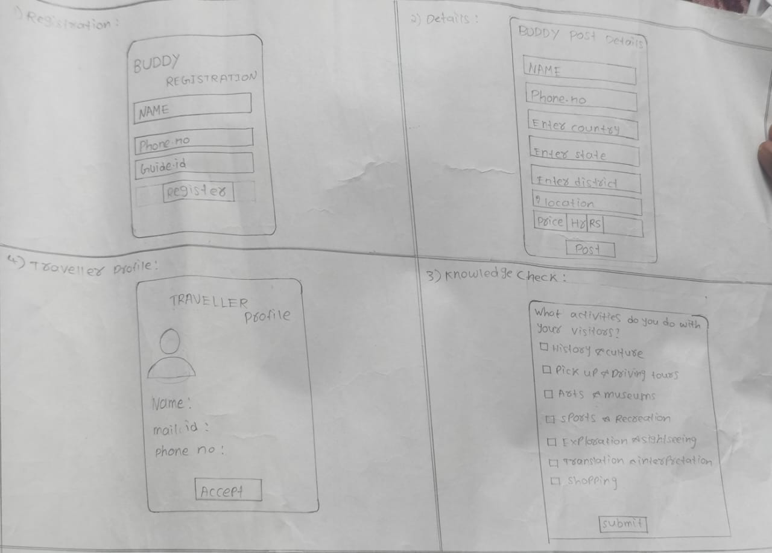

**Guide Marketing and Profile System:**

To make it easier for guides to look for clients, Travel Buddy creates a model profile system where guides can brag about their experience, abilities, and services. The prototype designed allows guides to upload pictures, list tours offered, and include client ratings in past experiences. The design would cover a clean and user-friendly interface by which guides can show their unique offerings in a professional manner for improved visibility of guiding potential clients.

**Guide Booking Management Tool:**

The guide has a booking management tool prototype, which can provide an easy management of bookings. Through it, he or she is able to view the details of the clients and update availability in real time. It may ensure that guides will be organized to respond quickly to inquiries from the traveller. This prototype focuses on simplifying the process or procedure involving the acceptance or refusal of bookings and managing its schedule.

**Low-Fidelity and High-Fidelity Prototypes**

At the prototype level, Travel Buddy creates low fidelity wireframes to describe functionality and flow of all features. Low fidelity wireframes are simple designs, focusing on layout and structure rather than making it aesthetically pleasing. The benefit of this level while testing the usability and navigation of the overall system with potential users is that low fidelity wireframes would be quite useful at this stage. For instance, a central dashboard for the traveller would first be created as a wireframe describing how different sections such as hotels, or activities would be arranged on the dashboard.

Once Travel Buddy gains feedback on low-fidelity prototypes, it moves onto high-fidelity prototypes. These are more refined and interactive, including polished design elements like colour schemes and typography as well as icons. This raises the fidelity of the prototypes so much that users can operate features as if in the final product, thus giving a better output when tested against user needs.

**Prototype Refining**

Prototypes can be amended to become closer to users' expectations through continuous testing and refinement. For example, following the initial feedback on the traveller dashboard, it may emerge that a user is going to want to view all his or her bookings at one time. The team adds a summary section at the very top of the dashboard. Guides may ask for easier ways to modify their profiles, in which case the team is going to simplify the profile editing section interface.

**3.Working of Travel Buddy**

| **Stage** | **Traveller** | **Buddy** |
| --- | --- | --- |
| 1. Registration | - Traveler fills out a registration form - Provides traveller_name, traveller_email, traveller_password, traveller_phone - Verifies email through a confirmation link | - Buddy fills out a registration form - Provides buddy_name, buddy_email, buddy_password, buddy_phone - Verifies email through a confirmation link |
| 2. Profile Setup | - Traveler completes profile setup (e.g., profile picture, bio) - Sets travel preferences and interests | - Buddy completes profile setup (e.g., profile picture, bio) - Sets availability and preferences |
| 3. Login | - Traveler enters email and password - If details are correct, logs into the system - If forgotten password, uses recovery options | - Buddy enters email and password - If details are correct, logs into the system - If forgotten password, uses recovery options |
| 4. Welcome Tour | - Traveler is guided through a welcome tour or tutorial - Introduced to key features and navigation | - Buddy is guided through a welcome tour or tutorial - Introduced to key features and navigation |
| 5. Dashboard | - Traveler views personalized dashboard - Options to view/edit profile, check travel plans, manage connections - Access to search for Buddies | - Buddy views personalized dashboard - Options to view/edit profile, manage travel requests, update availability - Access to search for Travelers |
| 6. Search & Discovery | - Traveler searches for Buddies based on criteria (e.g., location, interests) - Reviews Buddy profiles and sends connection requests | - Buddy searches for Travelers based on criteria (e.g., travel plans, interests) - Reviews Traveler profiles and accepts/declines requests |
| 7. Request/Match | - Traveler sends connection requests to selected Buddies - Receives notifications of connection requests from Buddies - Tracks request status | - Buddy receives notifications of connection requests from Travelers - Reviews and accepts or declines requests - Tracks request status |
| 8. Manage Connections | - Traveler manages existing connections - Communicates through messaging - Sets up travel plans and itineraries - Can block or remove connections | - Buddy manages existing connections - Communicates through messaging - Updates availability and manages schedules - Can block or remove connections |
| 9. Trip Details | - Traveler adds trip details (e.g., itinerary, destinations) - Edits or updates trip details as needed - Shares trip information with connected Buddies | - Buddy views trip details shared by Travelers - Updates or suggests changes to trip plans - Coordinates details with Travelers |
| 10. Notifications | - Traveler receives notifications for connection requests, messages, and trip updates | - Buddy receives notifications for connection requests, messages, and trip updates |
| 11. Communication | - Traveler uses messaging feature for communication - Keeps track of conversation history | - Buddy uses messaging feature for communication - Keeps track of conversation history |
| 12. Feedback | - Traveler provides feedback on Buddy experience - Rates the Buddy - Can also provide reviews and suggestions | - Buddy provides feedback on Traveler experience - Rates the Traveler - Can also provide reviews and suggestions |
| 13. Support | - Traveler accesses support for issues or queries - Utilizes FAQs, contact support, or help center | - Buddy accesses support for issues or queries - Utilizes FAQs, contact support, or help center |
| 14. Settings & Preferences | - Traveler updates account settings, privacy preferences, and notification settings | - Buddy updates account settings, availability preferences, and notification settings |
| 15. Logout | - Traveler logs out of the system - Session ends and user is redirected to the login page | - Buddy logs out of the system - Session ends and user is redirected to the login page |

**8.TEST AND FEEDBACK**

It is in the Test and Feedback stage that real users will take the prototypes for validating the design solutions and insights to be provided for further refinement. This stage would be crucial in an interface being built in the ideation and prototyping stages to meet the needs of users and solve the problems well enough. For Travel Buddy, the test and feedback stage is going to check the usability, functionalities, and overall user experience of features offered on the platform by both travellers and guides.

**Testing with Travellers**

Testing with travellers focuses on evaluating how well the platform's features address their key needs and pain points. The process will involve a number of steps:

User testing sessions The primary feature prototypes are tested on the travelers in user testing sessions. The prototypes vary from a centralized booking dashboard to a secure login system and real-time communication tools. In the session, the travellers are asked to perform specific tasks like booking a trip, accessing their travel documents, or initiating a chat with the guide.Testing with Guides

**Testing with Guides**

The testing with guides focuses on ensuring that the features developed to support their needs are effective and user-friendly. Major activities in the process entail:

**Scenario-Based Testing:** Presents scenarios to the guides that reflect real-life tasks they will carry out on the platform. These include updating their profiles, managing bookings, and communication with travellers. Through this simulation, the team is able to understand whether the needs of the guide are met appropriately and note any usability issues.

**Feedback Collection and Analysis**

All feedback in testing is really crucial to be improved on the platform. Among those processes, following ones deserve a mention:

**Feedback Analysis:**

It refers to processing that includes looking at what themes or what issues are particularly common on the feedback. Thus, it means analyzing the common pattern-whether it's usability related, functionality related, or user-experience related-and then organizing the feedback into related departments, such as booking modifications and usability, as discussed above.

Issues are ranked according to their impact on the user experience and according to frequency. Critical issues, which relate to critical functionalities, for example, management of bookings or the security of data, will be dealt with in the first iteration. This way, secondary issues like cosmetics or slight adjustments to usability will be dealt with in subsequent iterations.

**Satisfaction of the User and Improvement**

The test and feedback stage aims at the satisfaction of the user and at continuous improvement of the platform. The characteristics of this step comprise:

User Satisfaction Surveys Surveys are conducted to evaluate general user satisfaction with the platform. Questions are designed with focus on how well the feature set meets the needs of the user, its friendliness, and overall experience. High ratings for satisfaction clearly indicate that the platform is effectively addressing the needs of the users.

**Continuous Improvement:**

Even after the testing phase is over, the feedback loop will be continuous. Travel Buddy will continuously improve due to the feedback of the user that will be solicited even after the testing phase is over. Regular updates and refinements will ensure that Travel Buddy continues to change with user needs and industry trends.

**9. RE-DESIGN AND IMPLEMENTATION**

The solutions gathered previously and the feedbacks gathered are used to finalize any final adjustments before its proper implementation during this Re-design and Implementation stage. This makes a strong product in terms of user-friendliness and makes it robust with the thoroughness of proper deployment.

**Re-design Based on Feedback**

This is the phase that will make sure users' feedback from the test phase has been incorporated into redesign to improve functionality and usability of the platform. The process includes:

**Iterative Design:**

"Redesign" means that this process is iterative. It involves incrementally changing things and then repeating testing to make sure that the problems are well covered. In this case, it includes updating of prototypes, the extra rounds of user-testing, and refining based on the new feedback. For example, if the first redesign of the booking dashboard still has critical usability problems, then further refinements are made iteratively until this interface is deemed to be in line with expectations by users.

**Implementation of Final Design**

Once the re-designing is performed, then the ultimate design is put into a workable platform. Several key activities are associated with it:

**Development and Coding:** The ultimate design is realized as an executable product in development and coding. It involves development of all the features of a platform, integration of all those into a structured system such that all the functionalities work together seamlessly. For Travel Buddy, this would include development of backend and frontend elements, including booking management, secure login mechanisms, real-time communication, and much more.

**System Integration:**

This relates to ensuring that different parts of the platform can seamlessly work with each other. It includes connecting user interface elements with a backend database, third-party services, and the proper flow of data, whether into or out of the different components of the system. For instance, a centralized booking dashboard might need integration with the database so that it can query in real time for booking information which then updates the profiles of the users.

**Quality Assurance (QA) Testing:**

QA testing involves discovering bugs or anomalies and resolving them before launching the platform. This might involve feature or functional testing, where all the features should work without any issues; performance testing, or checking how reliable the system is when a lot of load is put on it; and security testing, which emphasizes the platform's ability to ensure user data is secure and safe. For Travel Buddy, it would entail testing its functionality-those related to alteration of bookings and secure storage of documents-to know that they are good and stable.

**User Acceptance Testing:**

A set of end-users would test the final version of the product to test its readiness for release before it meets the expectations of the users. This stage is very important in terms of validation on whether the product is ready for launch and if all problems or concerns identified have been addressed.

**Pre-Launch Preparation**

The final design is implemented and tested; the publication then focuses on preparing for the official launch of Travel Buddy, which includes several activities:

**Deploy:**

The platform is then available to users for deployment in the production environment. This means that users have to set up a server, configure cloud infrastructure, and ensure that any given platform has become accessible and scalable. It would mean that you take your application and deploy it to a live server so that it could handle user traffic well for Travel Buddy.

**Marketing and User Onboarding:**

Marketing activities will be carried out in order to popularize the platform and attract users upon its launch. For Travel Buddy, this will include the development of marketing campaigns as well as guides and tutorials in user manuals in order to assist both the travellers and guides when using the platform.

**Monitoring and Support:**

Given the mission, one soon realizes that continuous monitoring and support become indispensable for making sure that the platform will perform well and be able to overcome potential issues that could pop up after launch. For Travel Buddy, this includes setting up monitoring tools, setting up a support team, and ensuring that matters are promptly addressed.

**Continuous Improvement**

The re-design and implementation stage also sets the platform for continuous improvement. Following its launch, the platform is always under scrutiny in terms of any aspect in need of improvement as a result of user feedback. Key activities include:

**Post-Launch Feedback:**

The feedback from users who start using the platform gives a sense of what is still required to be improved. All the gathered feedback is used for iterative updates and improvements on the platform. If, for example, new feature requests or usability issues are reported, these are prioritized to improve the platform for the next update.

**Performance monitoring:**

The performance of the system is continuously monitored, thus keeping the platform reliable and efficient. Issues regarding speed, scalability, and stability are identified through performance metrics and solved accordingly.

**10.CONCLUSION**

In developing Travel Buddy, dealing with headwinds that surprise is actually the heartbeat of this success project. The essential takeaways include:

**Proactive Problem Solving:** Issues were quickly resolved in order for things to move freely and to address user needs.

Iterative improvement with feedback resulted in continuous refinement, always striving to improve functionality and experience on the platform.

**Collaborative Effectiveness:** Clear communication and teamwork were the prime factors in maximizing effective problem solving.

**Adaptability:** Flexibility and resilience over problems kept the project momentum going.

**11.FEATURE WORK**

Feature Work stage is when the development and feature refinement of the platform come with both priorities, designs, and eventually reflected in its implementation across the user experience. This stage is so important, because as part of the process at this stage, Travel Buddy will benefit by offering valuable functionalities in the needs of both travellers and guides while setting it apart from other competitions within.

**Prioritization of Features**

Feature work begins with feature prioritization. Features are prioritized according to their importance, impact on users, and their feasibility. The process includes:

The priority is established on the features depending on their needs and impact on the user experience. Features that satisfy core needs, like booking management and secure login, are given maximum priority.

**Roadmap Development:**

A development roadmap is created to detail how features would be developed. This roadmap specified milestones for testing and release of features so that the growth of the platform is well planned and in line with expectations from the users.

Resources such as development time and budget are pre-allocated based on prioritization of features. Thus, critical features get the attention and resources necessary to implement them successfully.

The features designed are to be developed. These include the following crucial activities:

**Feature Design:**

For every feature, detailed design work is undertaken. It includes forming wireframes and user flows to consider in detail how the feature is going to work and integrate into the platform. For example, the centralised booking dashboard design considers user navigation, information display, and interaction elements.

**Advanced Functionalities**

Advanced functionalities beyond the essential features will create a value-added proposition to help Travel Buddy stand out from competition. Key advanced functionalities include:

**Data Analytics and Reporting:**

Develop analytics tools that will help guide their performances, keep track of bookings, and assess user interactions to ensure that guides improve services by spotting data-driven choices.

Development of features follows an iterative process where functionalities have been based on user responses as they fine-tune and enhance functionality:

**Gathering Feedback**

Users' responses are continuously collected through surveys, usage data, and direct feedback channels in order to determine how good the features perform and where improvements are required.

**Feature Release and Evaluation**

Once the features have been built and tested, they are released to users and evaluated on performance:

**Performance Monitoring:**

After launching, features get monitored so that all such performance, adoption and errors can be traced later on. Usage rates as well as error logs based performance metrics are analysed so that features are working as they are supposed to work.

**Continuous Innovations**

Feature work is always continuous work with continuous innovations and improvement, including:

**Continuous Market Research:**

Identify emerging trends, user needs, and competitive features, and produce relevant new features and improvement.

It remains user-centric and focuses on the need and preference of users, even in the design and development of features. Such features are developed by constant updates based on user feedback as well as the changing trends.

**12. LEARNING OUTCOMES**

Travel Buddy Learning Outcomes Learning Outcomes is the reflection on key insights and lessons learned throughout the development of Travel Buddy. This is very important in the development process as it will be used to understand what impact a project can have on its stakeholders and identify areas needing improvement while applying those to future projects. It captures all the experience accumulated along the several phases of the project, from research up to the implementation phase, and finally the user feedback.

**Understanding the Needs and Problems of the User**

Developing Travel Buddy with deep learning outcomes, not only for understanding what the user requires but also for every challenge that a traveller or a guide might face in making this application.

Some key pain points were brought to light, particularly regarding hassle in dealing with multiple bookings, concerns over data security, and a bit of issues regarding communication with the local guides. Given the user-centric nature of the needs of the project and including features such as Centralized Booking Dashboard and among others, meeting those needs meant taking a user-centered approach to design.

**Why User Feedback?**

It was clearly learned through this process of design thinking that user feedback is at the heart of any end product development. The main takeaways are:

**Worth of Testing:**

Real user testing provided some crucial input about whether well the features meet the need. The feedback of the traveler and guide accounted for some vital refinements, hence it ensured the platform will be intuitive, functional, and even aligned to the expectations of the user.

**Ongoing Improvement:**

The project demonstrated that continuous improvement is necessary for success. The constant update and iteration based on user feedback were good ways to address issues, improve on features, and adapt to ever-changing user needs.

**Empathy and User-Centric Design:**

In the Empathize stage, it became very important to understand what users required from them. This user-centricity was foundational in informing which features were considered for designing and developing them directly from the pain points and needs of users.

**REFERENCES**

**Journal Papers**

[1] TourVista: Tour Guide Web Application H. M.C.H. Karunathilaka1,J.A.M.P. Jayasinghe2, W.M.A.S. Gunasekara3, W.T.R.P Fernando4, D.I. De Silva5, M.P. Gunathilaka6

[2] Comparative Study of Tourism Websites in India – With special reference to South India Dr. Kavita Chavali and Dr. Subrat Sahu

[3] A STUDY ON THE CONCEPTS OF DESIGN THINKINGMrs. P. Deepa

Assistant Professor, MBASRMIST Ramapuram, Chennai, Tamil Nadu, India

[4] Design Thinking: A Review PaperVikas T N1, Vinay C T2, Habeeba Amrutha Hegaddathy3, Rizwan N Shaikh4, Mrs. Vidya5

**Websites**

1. Buhalis, 2019 – Digital transformation in tourism and hospitality:  
   <https://journals.sagepub.com/doi/10.1177/14673584231198414>
2. Fitzpatrick, D. (2019). The Future of Travel: How Technology is Changing the Way We Explore the World - <https://www.theguardian.com/haval-ultra-hybrid/2023/feb/03/the-road-to-the-future-how-tech-is-changing-our-everyday-lives>
3. Paris, J. (2017). Solo Travel Companions: A Qualitative Study of Motivations, Experiences, and Challenges - <https://www.researchgate.net/publication/346452536_What_motivates_and_hinders_people_from_travelling_alone_A_study_of_solo_and_non-solo_travellers>
4. Gössling, S., & Hall, C. M. (2016). Tourism and Sustainability: Development, Impacts, and Management - <https://www.routledge.com/tourism-hospitality-and-events/tourism/tourism-developmentimpacts>
5. Couchsurfing: <https://www.couchsurfing.com/>
6. Meetup: <https://www.meetup.com/>
7. ToursByLocals: <https://www.toursbylocals.com/>